Symmetric Cryptography
Symmetric cryptography, also known as secret key cryptography, refers to a method where both parties share the same secret key for encryption and decryption. It is best suited for bulk encryption due to its speed and efficiency compared to asymmetric cryptography.

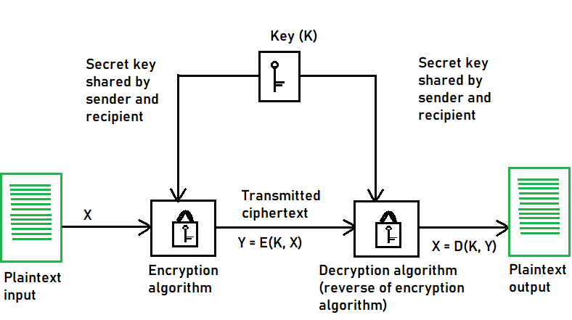

Types of Symmetric Key Cryptography:
1. Stream Ciphers
2. Block Ciphers

Stream Ciphers:
The encryption process begins with the stream cipher's algorithm generating a pseudo-random keystream made up of the encryption key and the unique randomly generated number known as the nonce. The result is a random stream of bits corresponding to the length of the ordinary plaintext. Then, the ordinary plaintext is also deciphered into single bits.

Block Cipher:
The result of a block cipher is a sequence of blocks that are then encrypted with the key. The output is a sequence of blocks of encrypted data in a specific order. When the ciphertext travels to its endpoint, the receiver uses the same cryptographic key to decrypt the ciphertext blockchain to the plaintext message.

The most common block cipher algorithms are:

1.Advanced Encryption Standard (AES):
- It has support for three-length keys: 128 bits, 192 bits, or 256 bits, the most commonly used one is a 128-bit key.
- It includes secure communication, data encryption in storage devices, digital rights management (DRM), and so on.

2. Data Encryption Standard (DES):
- In DES, the 64-bit blocks of plaintext are encrypted using a 56-bit key.
- This weakness caused by the small key size led to the development of a more secure algorithm, called AES.

3. Triple Data Encryption Algorithm (Triple DES):
- The development of the Triple DES, also called Triple-DES or TDEA, was triggered by the weak security resulting from the small key size in the DES.

Confusion and Diffusion:
According to the famous information theorist Claude Shannon, there are two primitive operations with which strong encryption algorithms can be built:
1. Confusion : It is an encryption operation where the relationship between key and ciphertext is obscured. Today, a common element for achieving confusion is substitution, which is found in both DES and AES.
2. Diffusion: It is an encryption operation where the influence of one plaintext symbol is spread over many ciphertext symbols with the goal of hiding statistical properties of the plaintext. A simple diffusion element is the bit permutation, which is used frequently within DES. AES uses the more advanced Mixcolumn operation.
The Feistel Cipher structure:
Feistel Cipher model is a structure or a design used to develop many block ciphers such as DES. Feistel cipher may have invertible, non-invertible and self invertible components in its design. Same encryption as well as decryption algorithm is used. A separate key is used for each round. However same round keys are used for encryption as well as decryption.
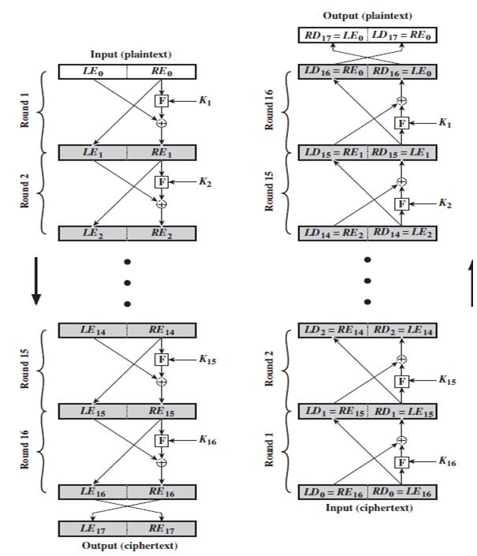

Data Encryption Standard (DES)
Data Encryption Standard (DES) is a symmetric block cipher. By 'symmetric', we mean that the size of input text and output text (ciphertext) is same (64-bits). The 'block' here means that it takes group of bits together as input instead of encrypting the text bit by bit. It is a block cipher that encrypts data in 64 bit blocks.
- It takes a 64-bit plaintext input and generates a corresponding 64-bit ciphertext output.
- The main key length is 64-bit which is transformed into 56-bits by skipping every 8th bit in the key.
- It encrypts the text in 16 rounds where each round uses 48-bit subkey.
- This 48-bit subkey is generated from the 56-bit effective key.
- The same algorithm and key are used for both encryption and decryption with minor changes.
Working of Data Encryption Standard (DES):
DES is based on the two attributes of Feistel cipher i.e. Substitution (also called confusion) and Transposition (also called diffusion). DES consists of 16 steps, each of which is called a round. Each round performs the steps of substitution and transposition along with other operations.
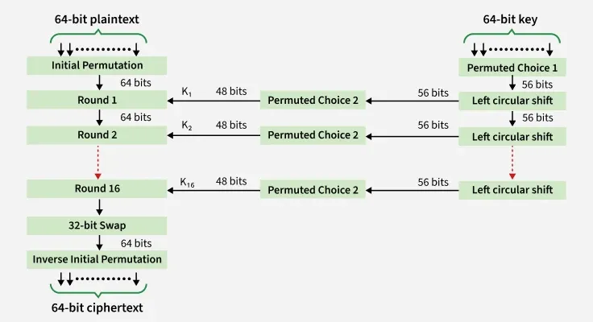
The DES (Data Encryption Standard) process involves several steps, organized into a series of rounds within a Feistel network structure. Here’s a breakdown of the steps:
1. Initial Permutation (IP):
The 64-bit plaintext block undergoes an initial permutation, where the positions of its bits are rearranged according to a predefined table.
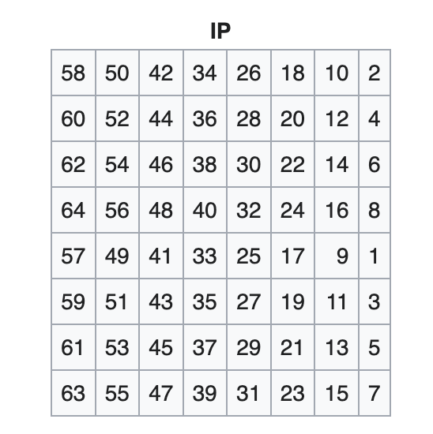
2. Key Generation:
The 56-bit key is expanded and divided into sixteen 48-bit subkeys, one for each round of encryption.
- Initial Key: The process begins with a 64-bit key, which is the user-provided secret key used to initiate the encryption.
- Key Permutation and Compression: 8-bit is being dropped and The 56-bit key undergoes an initial permutation(PC1 permutation) and compression. During this step, certain bits are selected and rearranged according to a predefined table. The result is a 56-bit permutation of the original key.
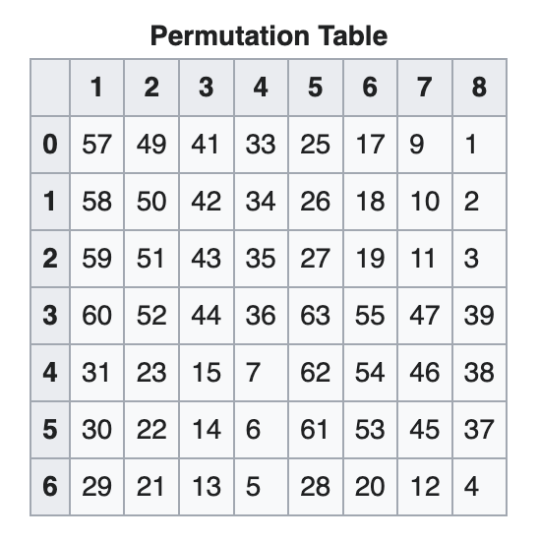
- Key Splitting: The 56-bit permuted key is then split into two 28-bit halves: a left half (C0) and a right half (D0).
- Left Shift: In each round, both the left and right halves of the key are independently rotated or shifted by a certain number of bits, creating a new combination of bits.
- Shift schedule = [1, 1, 2, 2, 2, 2, 2, 2, 1, 2, 2, 2, 2, 2, 2, 1]
- Concatenation and Compression: After the rotation, the left and right halves are concatenated and compressed to create a 48-bit round subkey for that specific round.
- Key Compression: The compression PC2 permutation changes the 56-bit key to the 48-bit key, which is used as a key for the corresponding round. Example: for round 1 we’ll use K1 and so on.
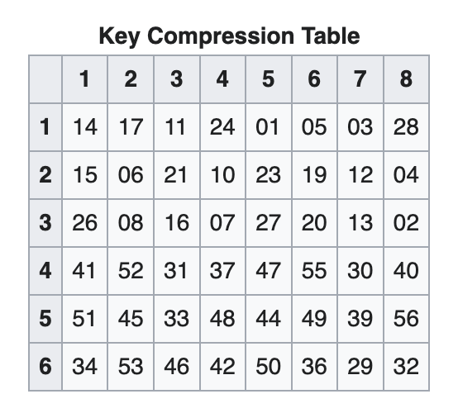
- Round-Specific Subkey Generation: The key expansion process involves creating sixteen round-specific subkeys, one for each round of encryption for C1 and D1 we’ll use C0 and D0 and for C2 and D2 we’ll use C1 and D1, and so on till C15 and D15.
- Sixteen Subkeys: This process is repeated for each of the sixteen rounds, resulting in a set of sixteen 48-bit subkeys (K1, K2, …, K16).

Advanced Encryption Standard (AES)

3. Rounds of Encryption:
- The data block is divided into two halves (L and R), and each round involves the transformation of one half based on the other half and the round key.
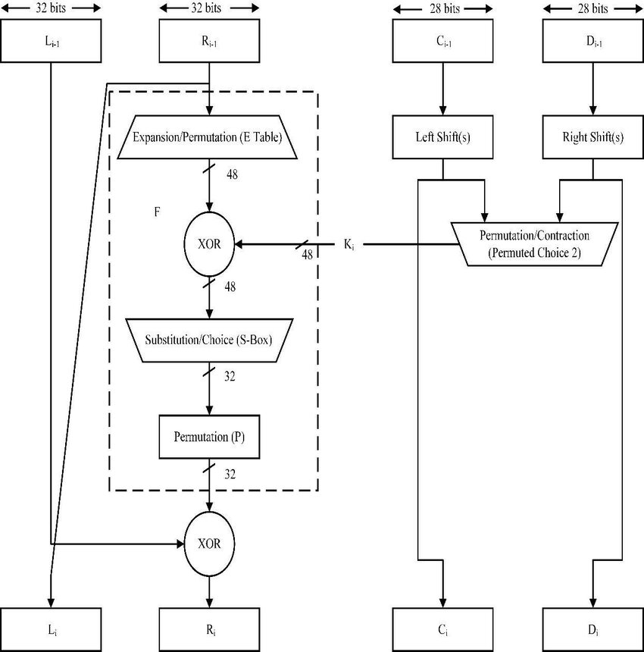
Single Round of Encryption:
- The f-Function:
the f-function plays a crucial role for the security of DES. In round i it takes the right half Ri−1 of the output of the previous round and the current round key ki as input. The output of the f-function is used as an XOR-mask for encrypting the left half input bits Li−1.
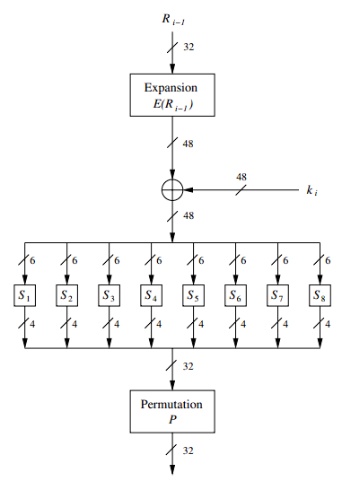
- Expansion/Permutation: The right half (R0) is subjected to an expansion operation, increasing its size(32-bit to 48-bit). This expanded right half is then XORed (bitwise exclusive OR) with the round-specific subkey (Ki) derived from the key schedule.
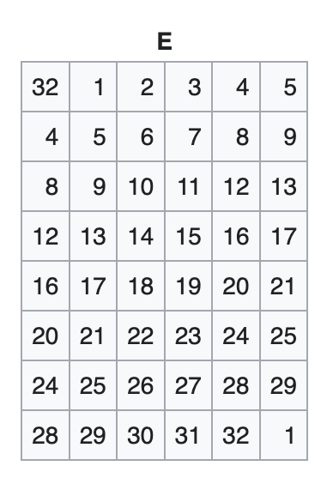
- Substitution (S-boxes): The result of the XOR operation is divided into eight 6-bit blocks. Each block is fed into a corresponding S-box (substitution box), which replaces it with a 4-bit output based on the S-box’s predefined substitution table. The outputs from all S-boxes are concatenated to form a 32-bit output.
- Permutation (P-Box): The 32-bit output from the S-boxes is subjected to a fixed permutation (P-box permutation). This rearranges the bits according to a predetermined permutation table.
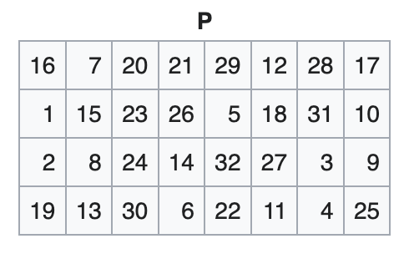
- XOR with Left Half: The output of the permutation step is XORed with the original left half (L0).
- Swap Left and Right Halves: The result of the XOR operation becomes the new right half (R1), and the original right half (R0) becomes the new left half (L1) for round 2 we’ll repeat these steps with respective key on L1 and R1 and so on.
- The transformation is accomplished through a combination of substitution (using S-boxes), permutation, and bitwise operations.
- The use of a different subkey for each round adds variability to the encryption process, enhancing security.
5. Final Permutation (FP):After the 16th round, the left and right halves are swapped one last time. The final result undergoes a final permutation (inverse of the initial permutation) to generate the 64-bit block of ciphertext.
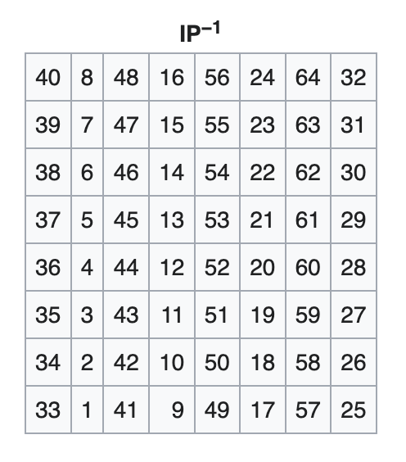

Cipher
Implementation of DES algorithm using Python
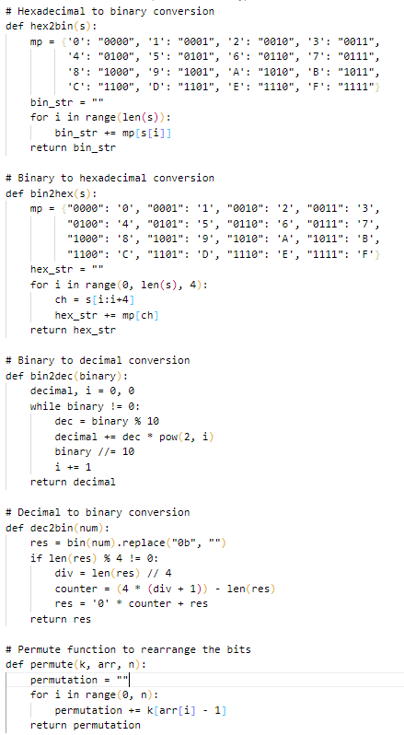
Code for Encryption:
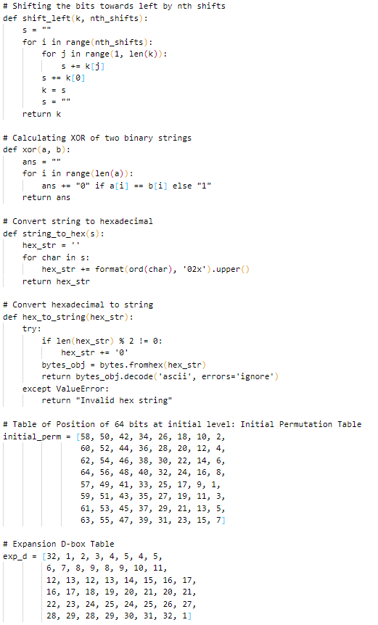

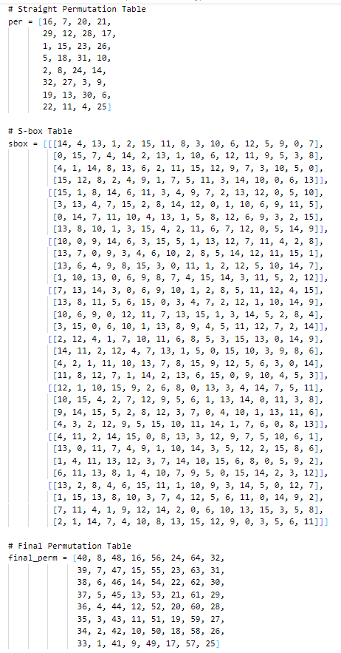
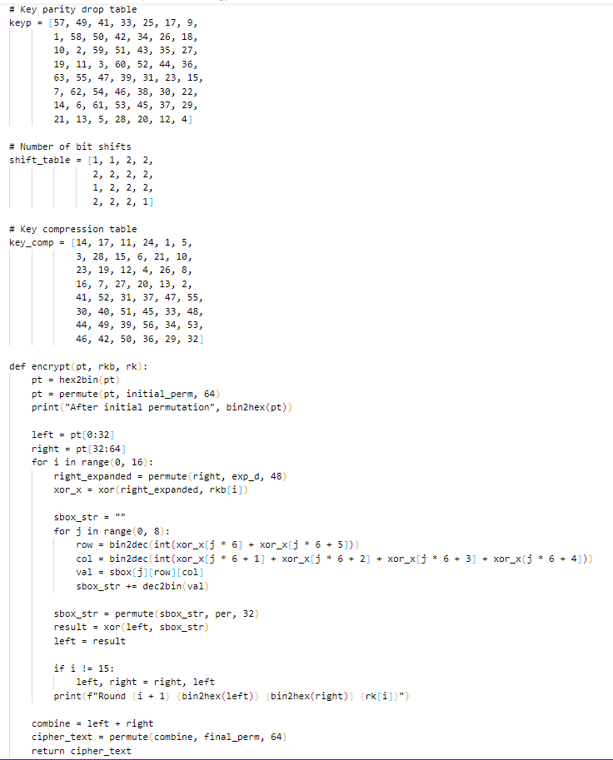

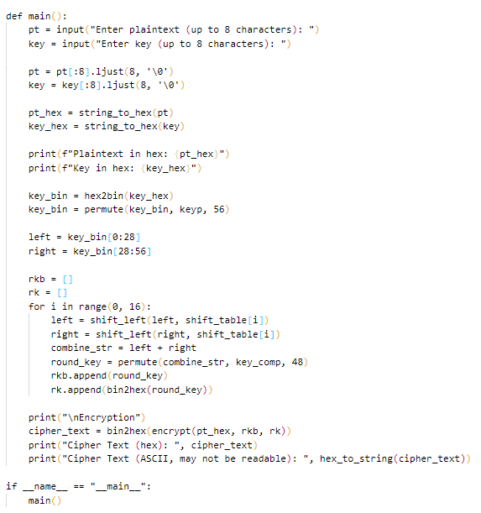
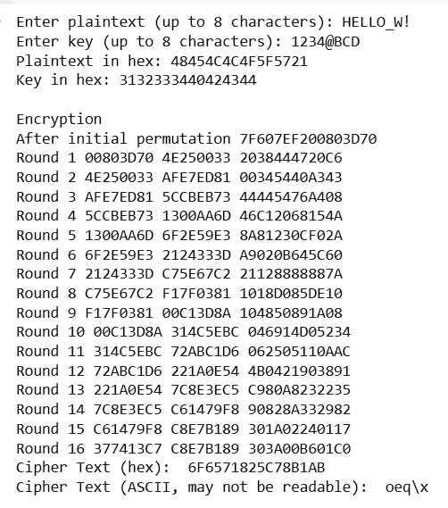
OUTPUT:

Code for Decryption:
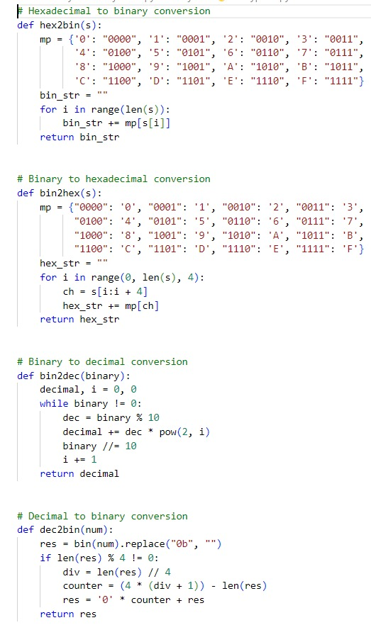
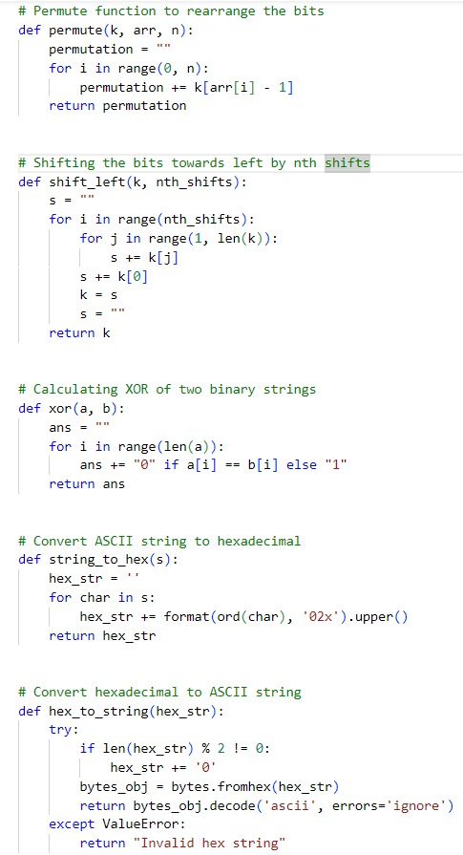

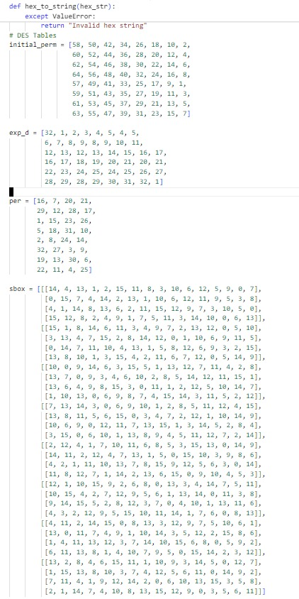

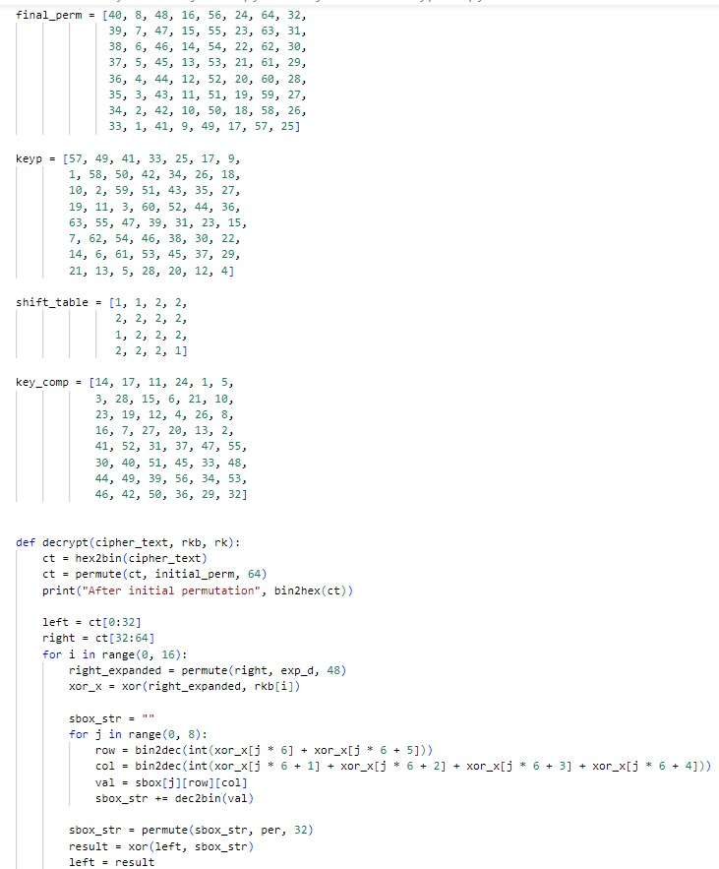

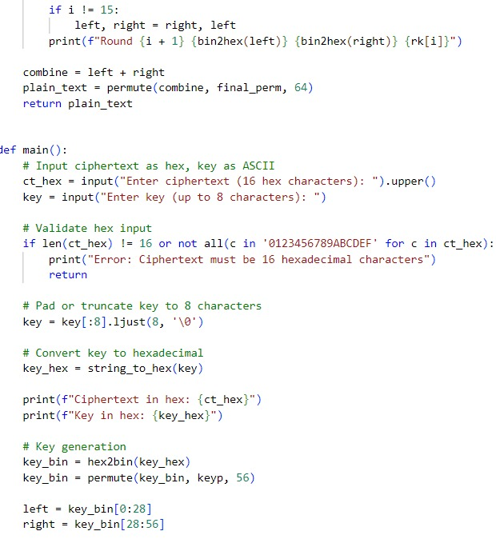
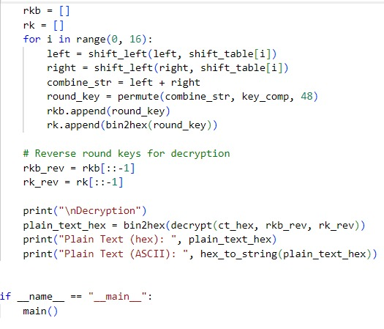
OUTPUT:
